**CEA-Leti Proposes Nine Research Tracks to Guide**

**ICT Industry’s Quest to Reduce its Carbon Footprint**

*Paper to Be Presented at IEEE ESSCIRC/ESSDERC Conference in September Warns of Unsustainable Increase in Power Use, Notes Potential Advantages for European Industry*

*In Collaborative Response*

GRENOBLE, France – Sept. 13, 2021 – In an ambitious and urgent proposal to improve energy efficiency in new microelectronic hardware and systems by a factor of 1,000 by 2030, CEA-Leti has challenged the ICT industry, especially in Europe, to collaboratively tackle the data deluge with greener electronics.

An eight-page paper to be presented at the European Solid-State Device Research Conference (ESSDERC) and the European Solid-State Circuits Conference (ESSCIRC) in September urges a systematic, green-tech approach of working simultaneously on five specific technology levels: process steps, circuits, architecture, software and algorithms – while also pursuing nine research tracks. The paper, “Overcoming the Data Deluge Challenges with Greener Electronics”, does not question the industry’s ability to dramatically reduce its carbon footprint, but it notes the major challenges. These include opening the closed R&D culture, adopting new ways of thinking and acting with urgency.

“Until 2023, the power consumption of data centers should remain stable at around 200 TWh but, with the slowing down of scaling benefits, we could see an exponential growth in their energy consumption as early as 2024, unless new technological innovations come into play,” the paper notes. “This exponential increase in energy consumption would not be sustainable.”

The paper also says that future significant power-use reductions will rely on improved fabrication processes, such as scaling, 3D integration and packaging, and on new computing architectures pushing new paradigms.

“The entire ICT ecosystem, from microelectronics, software and hardware designers to developers, producers, manufacturers and integrators, is facing an immense new environmental challenge: to cope with the data deluge and to reduce drastically the energy consumption of digital technologies,” said Jean-René Lèquepeys, CEA-Leti’s CTO. “This urgent, forward-looking proposal is an industry-wide call to action for the benefit of all economic sectors and society at large.”

**‘Radical Change in Mindset’**

The paper warns that the industry will need to exploit all the possible technological advances to meet this challenge. These include gains in resistive memories, 3D stacking and new computing paradigms, such as in-memory-computing, neuromorphic computing and quantum computing. In addition, maximizing efficiency and performance will require the R&D communities “to work closer together and embrace a real culture of co-design to optimize applications and algorithms, algorithms and Integrated Circuit (IC) architectures, IC architectures and technologies jointly.”

“We also propose to perform data-processing operations as closely as possible to the source, in order to curtail the energy consumption that comes with data transport between couputing and storage units,” the paper says. “Finally, finding strategies to reduce the use of water and alternatives to rare or difficult to recycle materials is an ecological emergency. Possible conflits between countries due to minerals scarcity are a direct threat to our industry.” adds Jean-René Lèquepeys, CEA-Leti’s CTO.

Processing data close to the source, known as edge computing, is consistent with the EU’s approach to limit use of cloud computing, to help ensuring data security. It also would significantly reduce energy consumption.

## Nine Research Tracks

CEA-Leti recommends nine research tracks to manage the data deluge taking into account sustainable electronics constraints.

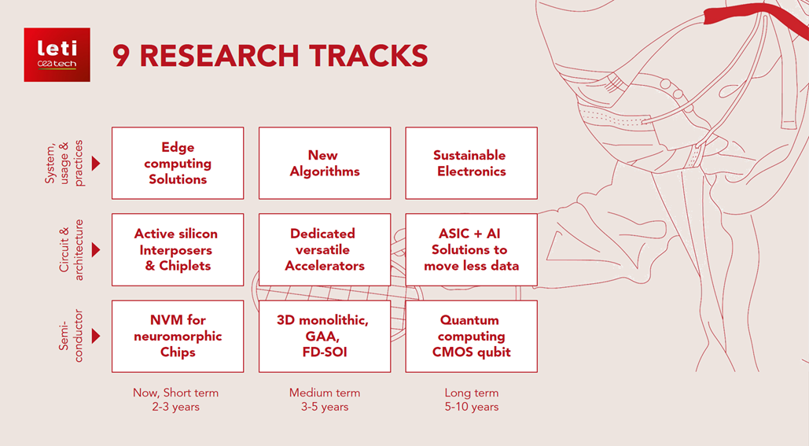

## System, Usage & Practices

## Develop sustainable electronics by accepting and deploying the huge R&D efforts it will require and by promoting the new mindset that must accompany this change.

## Develop edge-computing solutions to reduce the overall energy requirements and improve service quality.

## Investigate new algorithms and innovative approaches that could lead to implementations that are far more efficient in solving application problems.

## Circuit & Architectures

## Develop new electronic architectures using dedicated but versatile accelerators that exhibit optimized power consumption in a wide range of applications.

## Develop architectures and demonstrators based on active silicon interposers, chiplets and a 3D toolbox. Co-designing semiconductor processes and novel 3D electronic architectures can help improve computing performance significantly.

## Implement dedicated ASIC + AI solutions to move less data and lower power consumption, and develop in-memory computing and near-memory processing solutions with the adequate software and EDA toolbox.

## Semiconductors

## Use non-volatile memories to facilitate the implementation of neuromorphic chips that can deploy on-chip learning algorithms and a smart in-memory computing approach.

## Explore silicon-based devices and 3D structures to pursue equivalent scaling, down to the ultimate physical limits.

## Explore a silicon-based approach for quantum computing, including low-temperature CMOS technology for qubit control and readout, packaging based on a silicon interposer that can host qubits and electronics, and suitable error-correction codes.

**Competitive Edge for European Industry**

While recapping the importance of new digital technologies such as artificial intelligence, the Internet of Things and 5G/6G networks, the paper notes there is “an urgent need to take into account and address the increase in worldwide energy and rare-material consumption required to produce and operate digital technologies, and to orient worldwide R&D activities more and more towards sustainable electronics.” It cites the EU’s ambitious action plan adopted in March of this year, to accelerate the use of green digital technologies. “Indeed, Europe is calling for a concerted effort to boost its capabilities in these key technologies, since they are enablers for other technological developments and provide a competitive edge to the European industry,” the paper says.

Building the case for pursuing greener technologies in the time of the data deluge, the paper cites IDC research that humans and computers generated more than 64 zettabytes of data in 2020, a figure that is expected to exceed 2,000 zettabytes by 2035. “This escalation results from the fact that data is increasingly generated by machines (in 2018, only 44% of the data was produced by humans). It is expected that by 2022, 90% of all the data will be generated by machines (machine-to-machine communications) and by hundreds of billions of connected objects around the world. We are also witnessing a surge in multimedia data, such as image, video, speech and music, as opposed to ‘classic’ digital data (text and numbers), and an increase in the resolution of videos and pictures ”, and the appearance of 3D imaging.

“6G networks will have to address the need for greater performance but not at any price” adds Jean-René Lèquepeys. Ealier this year, CEA-Leti has launched the NEW-6G initiative across the UE telecom and semiconductor community to lay the groundwork for future 6G wireless networks,  while meeting societal expectations and sustainability requirements.

The paper also says the industry must address the three stages of the data processing chain – data transmission to processing, data analysis and exploitation and data storage and processing – while ensuring systems are secure and resistant to attacks and protect personal and corporate data in compliance with Europe’s General Data Protection Regulations (GDPR).

***About CEA-Leti (France)***

*CEA-Leti, a technology research institute at CEA, is a global leader in miniaturization technologies enabling smart, energy-efficient and secure solutions for industry. Founded in 1967, CEA-Leti pioneers micro- & nanotechnologies, tailoring differentiating applicative solutions for global companies, SMEs and startups. CEA-Leti tackles critical challenges in healthcare, energy and digital migration. From sensors to data processing and computing solutions, CEA-Leti’s multidisciplinary teams deliver solid expertise, leveraging world-class pre-industrialization facilities. With a staff of more than 1,900, a portfolio of 3,100 patents, 10,000 sq. meters of cleanroom space and a clear IP policy, the institute is based in Grenoble, France, and has offices in Silicon Valley and Tokyo. CEA-Leti has launched 69 startups and is a member of the Carnot Institutes network. Follow us on* [*www.leti-cea.com*](http://www.leti-cea.com/) *and @CEA_Leti.*

***Technological expertise***

*CEA has a key role in transferring scientific knowledge and innovation from research to industry. This high-level technological research is carried out in particular in electronic and integrated systems, from microscale to nanoscale. It has a wide range of industrial applications in the fields of transport, health, safety and telecommunications, contributing to the creation of high-quality and competitive products.*

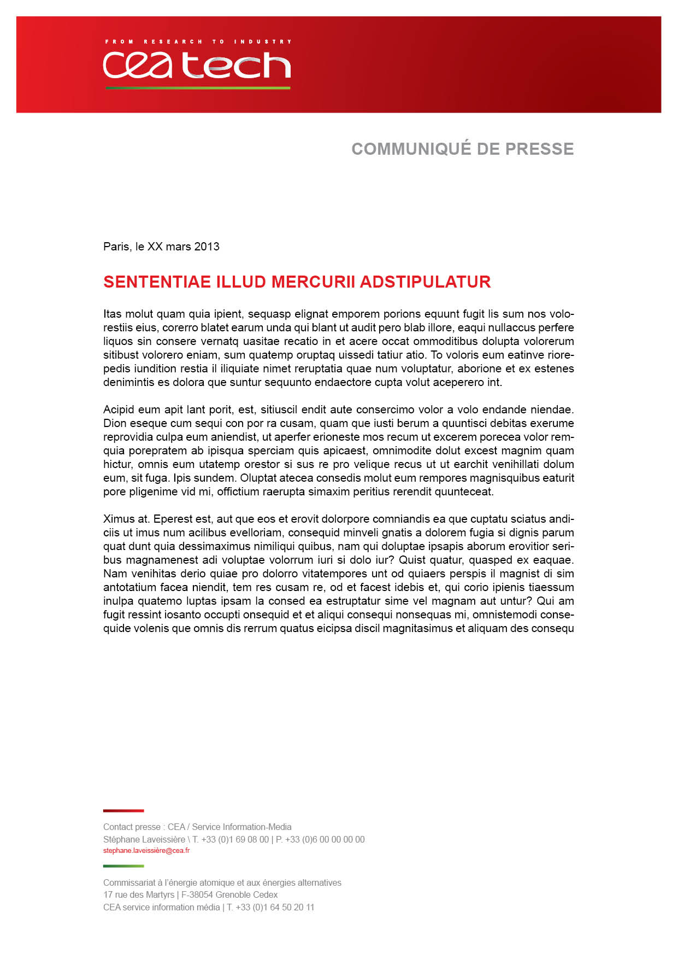**Press Contact**

Camille Giroud

+33438783713

[Camille.giroud@cea.fr](mailto:Camille.giroud@cea.fr)